 Priyadharshini N,

Au211521243121

**TNSDC-GENERATICE AI PROJECT**

**AI CODE EXPLAINER TOOL**

# Generative AI Project-

# AI Code Explainer App using PaLM API



PROBLEM STATEMENT

PROJECT OVERVIEW

WHO ARE THE END USERS?

SOLUTION

THE WOW IN MY SOLUTION

MODELLING TOOLS

RESULT



**AGENDA**

# PROBLEM STATEMENT

Develop a Python Code Explainer application powered by PaLM API to facilitate comprehensive understanding of Python code snippets. The application should utilize generative AI techniques to provide detailed explanations of Python code functionality, aiding users in grasping complex coding concepts efficiently. This project aims to enhance coding education and comprehension by leveraging advanced natural language processing capabilities to generate concise and accurate explanations tailored to various Python code inputs.

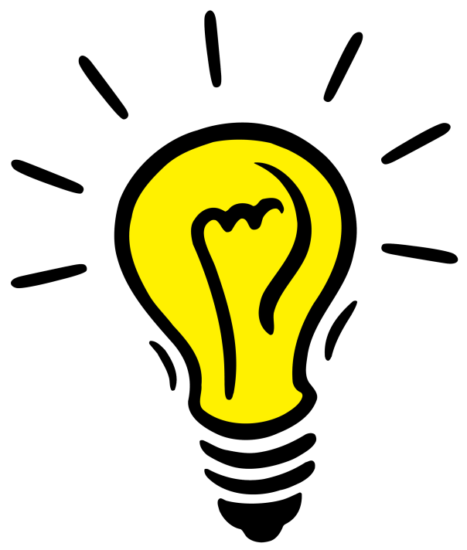

# PROJECT OVERVIEW

The Python Code Explainer App powered by PaLM API aims to revolutionize the way users comprehend and learn Python programming. Users can input Python code segments into the app, and the PaLM API generates comprehensive explanations, breaking down the functionality and logic behind the code. This project seeks to enhance coding education by offering an intuitive platform for learners to understand complex Python concepts effectively. With its user-friendly interface and advanced AI capabilities, the Python Code Explainer App empowers users to elevate their coding proficiency and deepen their understanding of Python programming.



**WHO ARE THE END USERS?**

1. Students and Learners
2. Programmers and Developers
3. Educators and Instructors
4. Coding Enthusiasts
5. Tech Communities and Forums



## YOUR SOLUTION

The Python Code Explainer App utilizes PaLM API and generative AI techniques to provide comprehensive explanations for Python code snippets. Users can input code segments, and the app generates detailed explanations, breaking down the functionality and logic behind the code in an easily understandable manner.

# THE WOW IN YOUR SOLUTION

The Python Code Explainer App offers a seamless and intuitive solution for understanding Python code, powered by cutting-edge AI technology. With just a few clicks, users can receive detailed explanations for complex code snippets, unlocking a new level of efficiency and comprehension in their coding journey. The wow factor lies in the app's ability to bridge the gap between intricate code logic and user-friendly explanations, revolutionizing the way individuals learn and engage with Python programming.

Top of Form

The Python Code Explainer App utilizes PaLM API, a generative AI model trained on vast amounts of text data, including Python code and explanations. PaLM employs advanced natural language processing techniques to understand and interpret Python code snippets, generating concise and accurate explanations tailored to users' inputs. This enables the app to deliver comprehensive insights into code functionality and logic, facilitating effective learning and comprehension for users.



# MODELLING

Teams cam add wireframes

# RESULTS

The Python Code Explainer App delivers detailed explanations for Python code snippets, enhancing users' understanding of coding concepts efficiently. With its AI-powered solution, users save time and gain valuable insights to improve their coding skills and problem-solving abilities.

Demo Link

[https://e98fb0232b97e23ff7.gradio.live](https://e98fb0232b97e23ff7.gradio.live/)